**Distribute Your App Across a Swarm Cluster**

This section will guide you to**:**

* Deploy a Docker container on Docker swarm and have multiple nodes inside a cluster.

This lab has four subsections, namely**:**

4.5.1 Setting up a Docker instance

4.5.2 Setting up a Docker swarm with multiple nodes

4.5.3 Deploying a custom Docker image to a Docker swarm cluster

4.5.4 Pushing the code to GitHub repositories

**Step 4.5.1:** Setting up a Docker instance

* Docker version 18.09.7 is installed in your practice lab.
* To verify the installation:

1. Open the command-line interface
2. Type in the command:

*docker --version*

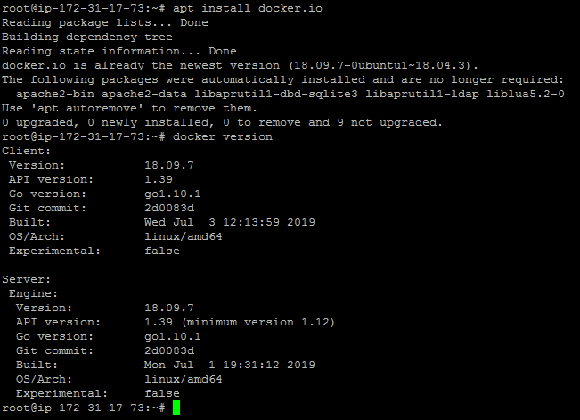

**Step 4.5.2:** Setting up Docker swarm with multiple nodes

* Edit the **/etc/hosts** file across the two nodes via **gedit** or **vim** and make the following changes:

172.31.17.73dockermanager

172.31.86.69dockerworker1

* After modifying the host file with the details mentioned above, check the connectivity with **ping** between all the nodes
* From Docker Manager Host instance:

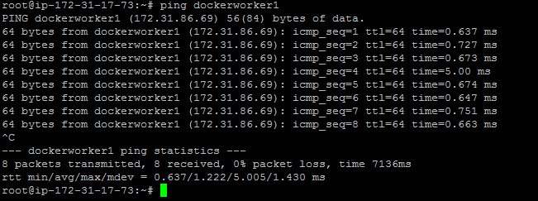

* From Docker Worker Node instance:

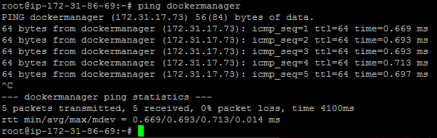

* Initialize the Docker swarm mode by running the following docker command on the **dockermanager** node

docker swarm init --advertise-addr<manager node IP address>

docker swarm init --advertise-addr172.31.17.73

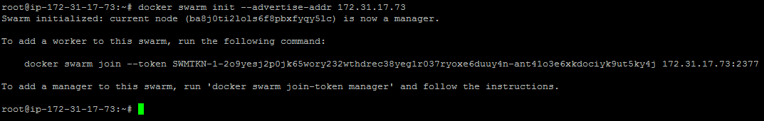

* Once the swarm cluster is initialized, allow the ports mentioned below in security groups





* While initializing the Docker swarm cluster, you will get docker swarm join command which can be executed on node manager to add node to swarm cluster
* Run the command below to see the node status

docker node ls



**Step 4.5.3:** Deploying a custom Docker image to a Docker swarm cluster

* Create service in Docker swarm cluster

docker service create --name webapp --publish 8080:8080 --replicas 2 jocatalin/kubernetes-bootcamp:v1

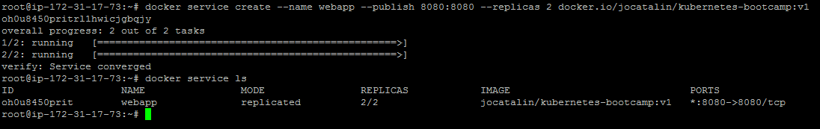

* You can now validate if Docker containers got deployed on both nodes or not using the command below

docker service pswebapp

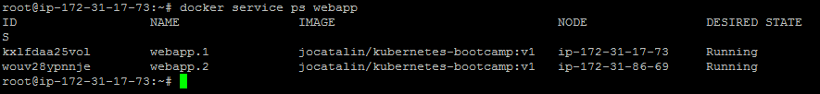

**Please Note:** We can validate the application using the **curl** command to see if the application is up and running.

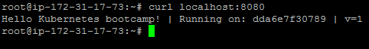

**Step 4.5.4:** Pushing the code to your GitHub repositories

* Open your command prompt and navigate to the folder where you have created your files.

**cd <folder path>**

* Initialize your repository using the following command:

**git init**

* Add all the files to your git repository using the following command:

**git add .**

* Commit the changes using the following command:

**git commit . -m “Changes have been committed.”**

* Push the files to the folder you initially created using the following command:

**git push -u origin master**